Analyzing Data

- Top 10 Companies based on Quality Score

SELECT
symbol,
name,
sector,
quality_score,
pe_norm,
ebitda_norm,
divy_norm,
ps_norm,
pb_norm
FROM `projectspractice12.sp500dataAnalysis.sp500data_qualityScore`
ORDER BY quality_score DESC
LIMIT 10;

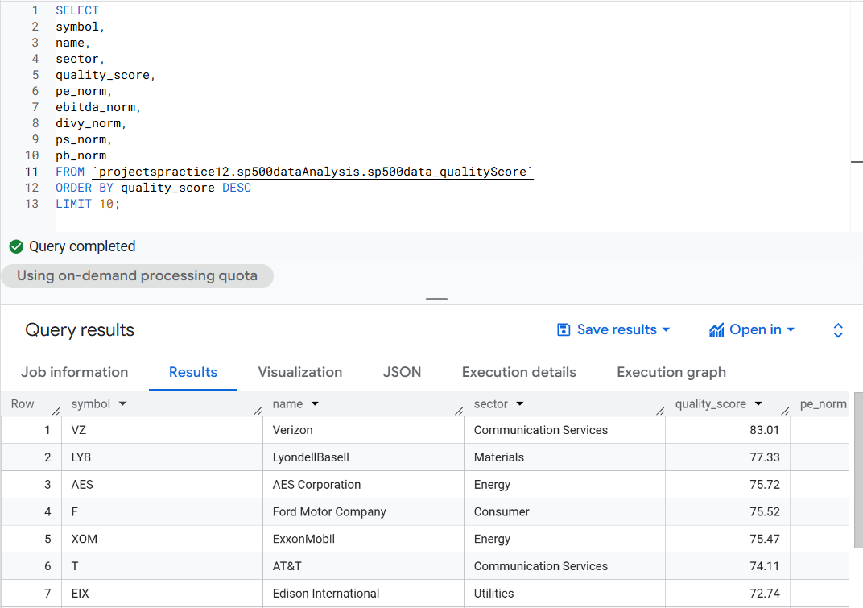

- Bottom 10 Companies based on Quality Score

SELECT
symbol,
name,
sector,
quality_score,
pe_norm,
ebitda_norm,
divy_norm,
ps_norm,
pb_norm
FROM `projectspractice12.sp500dataAnalysis.sp500data_qualityScore`
ORDER BY quality_score ASC
LIMIT 10;

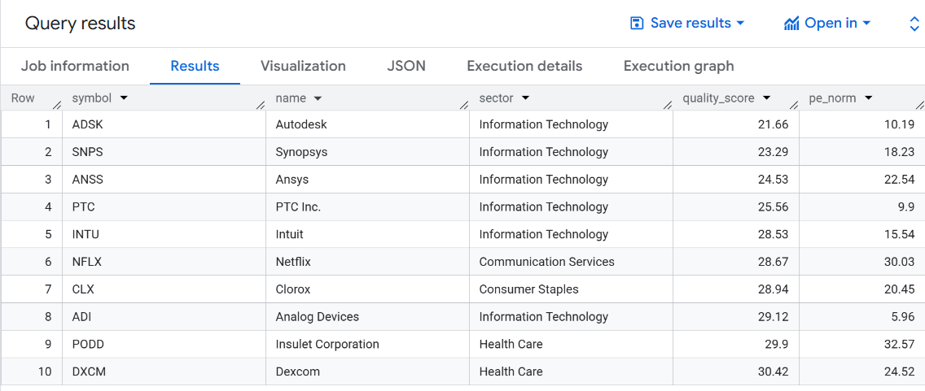

- Sector Leaders

SELECT
sector,
symbol,
name,
quality_score,
rank_in_sector
FROM `projectspractice12.sp500dataAnalysis.sp500data_qualityScore`
WHERE rank_in_sector = 1
ORDER BY quality_score DESC;

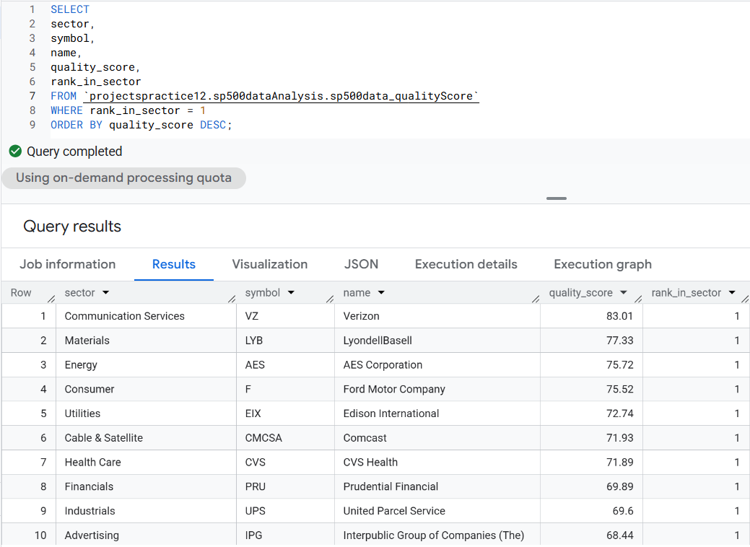
- Sector Aggregates

SELECT
sector,
ROUND(AVG(quality_score), 2) AS avg_quality_score,
MIN(quality_score) AS min_quality_score,
MAX(quality_score) AS max_quality_score,
COUNT(*) AS n_symbols
FROM `projectspractice12.sp500dataAnalysis.sp500data_qualityScore`
GROUP BY sector
ORDER BY avg_quality_score DESC;

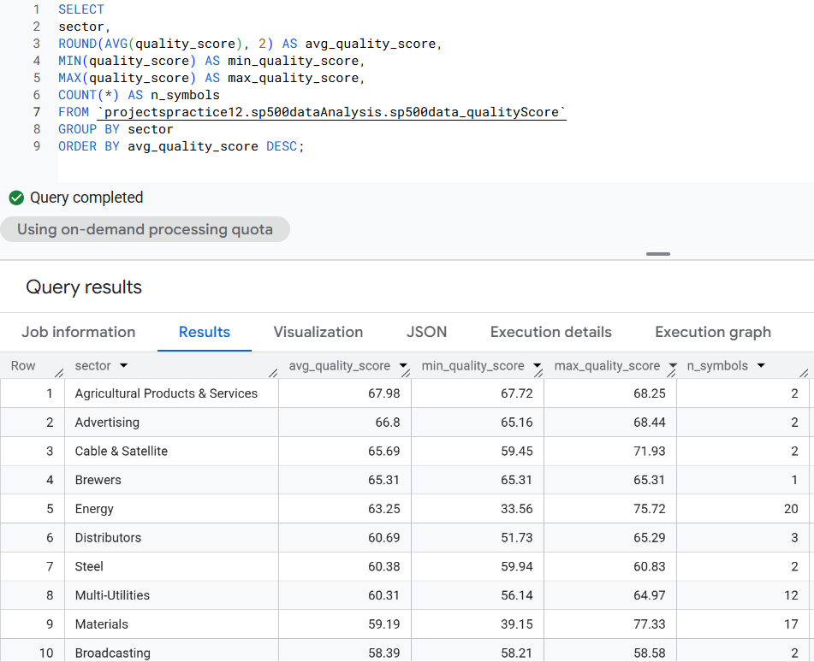

- Drivers of Quality Score

SELECT
CORR(quality_score, pe_norm) AS corr_pe,
CORR(quality_score, ebitda_norm) AS corr_ebitda,
CORR(quality_score, divy_norm) AS corr_divy,
CORR(quality_score, ps_norm) AS corr_ps,
CORR(quality_score, pb_norm) AS corr_pb
FROM `projectspractice12.sp500dataAnalysis.sp500data_qualityScore`;

